Andy Warhol

Andy Warhol, otherwise known as ‘Andrew Warhola’ was an American artist who got interested in being the leading figure in the Pop Art movement. He was born in Pittsburgh in Pennsylvania, and he studied at Carnegie Institute of Technology in between 1945 and 1949. He moved to New York in 1949 where he was working as a commercial artist for magazines, and he changed his name to Warhol.
Pop Art is an art based on modern popular culture and the mass media, especially as a critical or ironic comment on traditional fine art values.
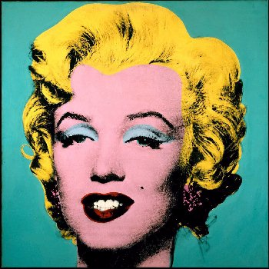
One of his works of Pop Art was the one he did on Marilyn Monroe. He made this on the occasion on Marilyn Monroe’s suicide in August of ’62 and that Warhol used this image for his screen-printing and was fascinated with morbid concepts. So, this work of Pop Art was made by screen-printing.
Warhol made this Pop Art, because he wanted to dedicate Marilyn Monroe on her death.
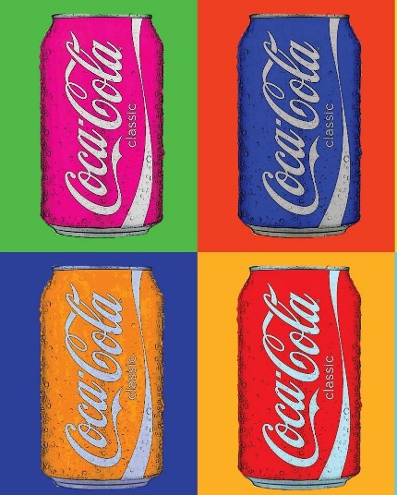
All of his main work was created in the 1960s which included the Monroe picture, but he was also famous for making Pop Art screen-printings of other famous people he knew of like ‘Her Majesty the Queen’ and advertising products/brands names like ‘Marmite’ and ‘Coca-Cola’.

SEB SANDFORD
Unit 8

