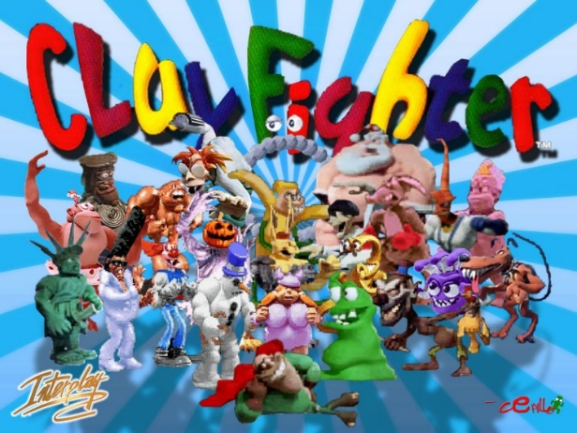

Part 1
What type of game is Clayfighter? | ClayFighter is a fighting game released for the Super NES in 1993.
Who was it aimed at?  (who is the target audience?) | The game had two age groups, 11 & under and 12 & over.
Why was it made? | ClayFighter's design was originally made to compete with fighting games such as Mortal Kombat, but without the heavy violence and gore.
How does it differ from other games of the genre?  How is it unique? | The game itself parodies other fighting games. It uses a 3-level bar for super combos like in Street Fighter Alpha and uses parries like Street Fighter III, and many of the super attacks are noticeably variations of attacks from the Street Fighter series. It also features a combo system similar to Killer Instinct, although it makes fun of the combo names (for example, "Itty Bitty Combo", or "Triple Brown Betty Combo").  I think the characters are made out of animated clay
With the target audience in mind, do you notice any common thread or theme with the characters? | Bad Mr. Frosty is in the winter season, and Ickybod Clay is in the Halloween season. So, the game is genially aimed at children.
From the character list..  Is there a character that stands out to you?  If so, why? | Bad Mr. Frosty - A snowman with a bad attitude. His special attacks include throwing snowballs, spitting sharp balls of ice, sliding along the ground and kicking his opponent, and turning into a snow boulder and rolling into his opponent.  This character appeals to me, because I like winter, and I like throwing snowballs and I think it’s very funny.
Are there any ‘Special Attacks’ that stand out in the sense that they are either ‘clever’ or ‘funny’ If so, which are they? | I think Bad Mr. Frosty is clever at fighting other characters in a video game like this. I had no idea that he spins his head around every time he wins a match and he feels happy.

Part 2
Requirements of the Brief
To Consider
The who, why, what and where?!
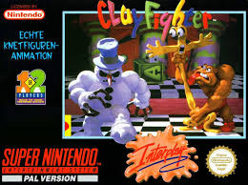
Step 1 – Read the brief!
Then consider…

1: Target Audience? So Who is it then?

2 What is the purpose of the product? (why produce it?)
Please underline what you think might be the correct answer…
- To inform
- To educate
- To entertain
- To provide a service

3) Platform!
We know it’s a game but for which platform?
Please underline (You may underline as many as you wish)
- Console
- Smartphones
- Tablets
- PC’s
- Handheld devices

4) Ethical Considerations
When designing games or characters you must be aware of the potential ethical issues of what your creating?
You need to consider ….
- whether it is appropriate or not for the audience.
- Who or what are you representing? Again, is it appropriate?
How do these considerations impact on the planning of your character?
Part 3
The Characters in the game are generally either…
- Iconic ….eg Statue of liberty
- Child friendly creatures gone bad i.e. Snowman or Halloween characters
- Comic stereotypical creations
All aimed of course at either an international or American centric market…
Research and consider Characters that may appeal to your target audience for a UK market?
You may choose to consider seasons and festival’s or maybe just current trends or comedy characters.
Please remember the original Clay fighter came out over 20 years ago. Some of their characters would not be ok now! (can you see any examples)
You can go to and watchgame videos for inspiration!
The X Factor
London Eye
Thursday Curseday
River Thames
Nemo
Dory
Fluke
Rudder
FISHINATOR
Shark
Jellyfish
Squid
Sectopus
Goldfish
Charlie Shark
Sharky
Tennis Eyes
Marble Eyes
Clams
Oyster shells
Eels
Seal
Octopus
Dolphins

Self directed Study! 2-3:30

Start getting Visual!
Your pitch will need to evidence planning and your thought process.
Start to create …
a Moodboard –picture images of similar characters or design traits
Sketches
Mind Maps

At this stage you can be as silly as you like and have fun!
Think of as many different characters as you can.

