Copyright Constraints
© Where and why is this symbol used? | It tells you if you posted something online that is copyrighted from someone or something.
Give examples of material which could be subject to copyright laws that you might use in your Weebly websites? | 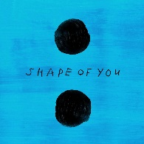  Ed Sheeran – Shape of You  Columbia & SONY logos
What is plagiarism? | Plagiarism is the practice of taking someone else's work or ideas and passing them off as one's own.
How can you avoid plagiarising someone’s work? | You can avoid plagiarising someone’s work by make sure that you write your own paragraph in your own words instead of copying the work of someone’s book/speech/newspaper article.
How could you acknowledge sources? | You can acknowledge sources by using referencing conventions like showing that we have done the info-gathering work expected of us, and giving proper credit to others for their information and ideas.
What does it mean to obtain permissions and why would you do this? | Obtaining permissions mean that you need to determine if permission is needed from your teacher or someone in your family, because they need to know if it is okay to borrow someone else’s work for your own project.

