Famous Animators
Historical Contexts and Influence

Willis H O’Brien
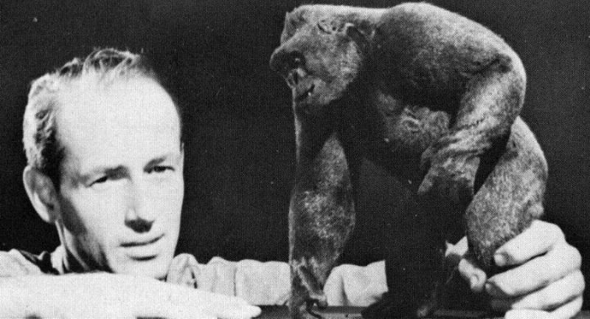
What was Willis H O’Brien’s most famous film?
King Kong
When was it made?
Made in 1933
Why was Willis so important?
Willis was important, because his use of stop-motion animation influenced a great many future filmmakers, most notably, Ray Harryhausen and Tim Burton.

Ray Harryhausen

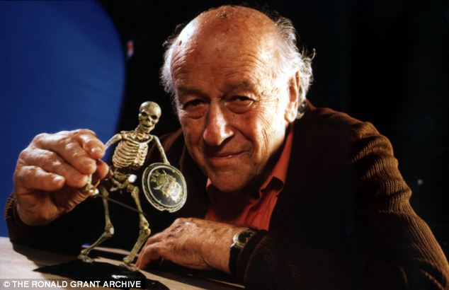
Who inspired Harryhausen?
Willis H O’Brien
What was his most famous film?
Jason and the Argonauts
What country was Harryhausen from?
Harryhausen was born in Los Angeles, California on June 29th 1920 and died in London, England in May 2013.

Jan Svankmajer
What country was Jan Svankmajer from?
Czechoslovakia
What political system was this country ruled under?
The Communist Party of Czechoslovakia
What type of artist was Svankmajer?
A surrealist Czech animator
What themes often occurred in Svankmajer’s work?
Communism, political themes + issues, dialogue

Hayou Miyazaki
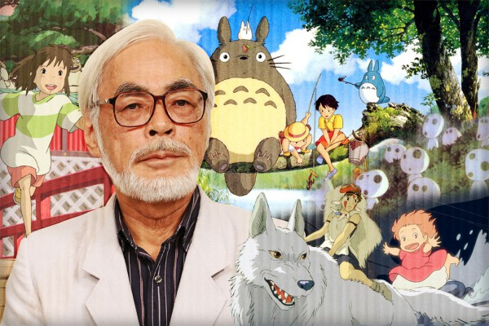
What country is Miyazaki from?
Tokyo, Japan.
What type of animation does Miyazaki produce?
Animes

What is the name of Miyazaki’s production company?
Studio Ghibli
What are the themes of Grave of the Fireflies?
World War 2 in Japan, animation for adults, themes of death, frightening scenes
Would you call Grave of the Fireflies a children’s film?
I would call Grave of the Fireflies a movie for adults.

John Lasseter
What company did John Lasseter work for?
Walt Disney Animation Studios, PIXAR Animation Studios
Which entrepreneur and technologist helped fund and create Pixar?
Steve Jobs
What role did Lasseter have at Disney?
What is John Lasseter’s legacy to animation?
Head of PIXAR Animation Studios
To completely change the world of animation

