Creative Digital Media Production Unit 1: Lesson 1
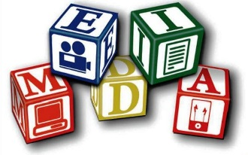
What does the term media mean to you?
Media to me means that you make movies in different parts of the globe and you edit them to make it look realistic. It also means that you find adverts online. It also means a digital product that is made to make a profit.
Write down the official definition of the term media...
Products made for mass, audience and consumption. A mean of communication, such as radio, television, newspapers, and magazines, that reach or influence people widely.

Make a list of all the different media sectors you can think of...
Video games | Art | Photography
Magazines | Feature films | Graphics/motion graphics
Digital Media | Animation | Music
Social Media (Web 2.0) | Posters | Books
Advertising | Podcasts | Radio
Websites | Apps | Newspapers
In each sector can you identify two examples of products (use images where you can)?

Sector | Product
Animation | 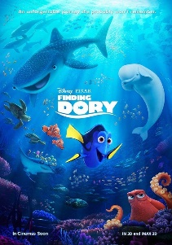  Finding Dory (2016)
Podcasts | www.bbc.co.uk/podcasts
Radio | 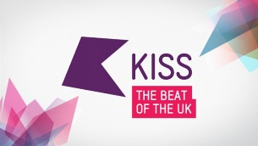  KISS FM UK
Websites | www.disney.com
Posters | 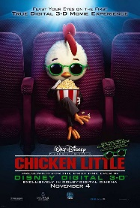  Movie posters
Music | Michael Bublé
Video Games | 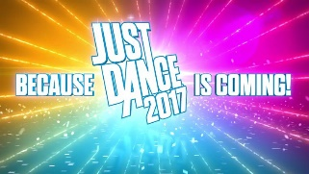  Just Dane 2017
Apps | 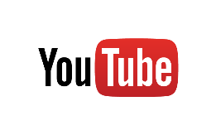  YouTube
Books | 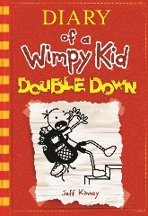  Diary of a Wimpy Kid
Art | Andy Warhol

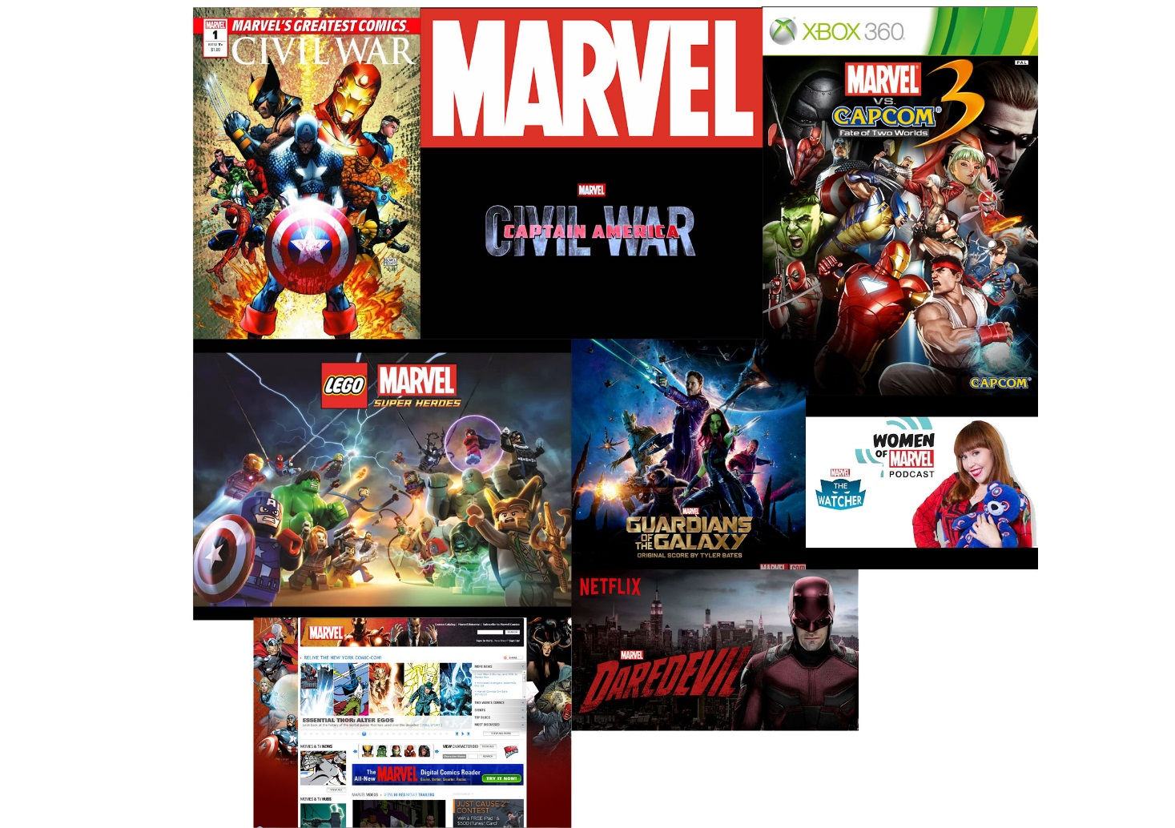
Often, digital media sectors do not exist independently. They often overlap and are connected. This is referred to as synergy.

What are the benefits of synergy?
- Better Products
- Bigger profits
- Better distribution
- More ideas

