Creative Digital Media Production Unit 1: Lesson 2
What do we mean by a media platform?
Media platforms are a digitized platform for media that allows real-time and/or delayed delivery of video, audio and/or data.

List some of the different platforms that are
Netflix | YouTube | Twitter
Tumblr | NOW TV | Pinterest
Amazon Prime | PSN | Xbox Live
Spotify | Apple Music | Facebook
Flickr

What do we mean by a media device?
Media devices are devices that can access digital media.

List some different devices (use pictures where you can)...
Device | Image
iPhone 7 & 7 Plus | 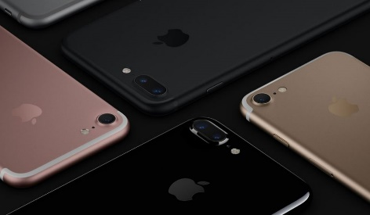
Laptops | 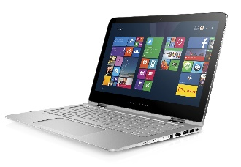
Nintendo 2DS | 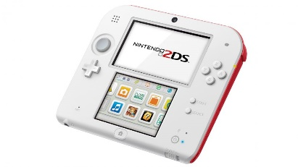
iPad Pro | 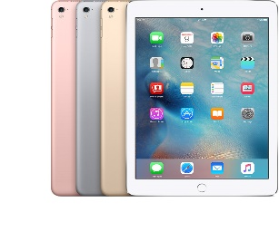

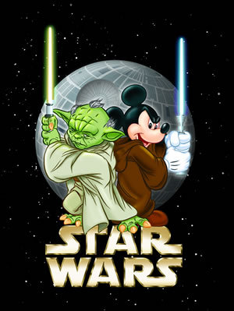
Disney are releasing a new trailer for their upcoming film Rogue One: A Star Wars Story. Their target audience for this trailer is 14-16 year olds. Disney want you to create some research on what platforms and devices 14-16 year old use and how often so that they know where to show the trailer to gain maximum exposure to their target audience.

