Creative Digital Media Production Unit 1: Lesson 3
What does multimedia mean?
Multi = Many, Media = Products that reach a wide audience like music or films.
Therefore, a multimedia device is a device that plays different forms of media.
List some different multimedia devices (use pictures too!)...
Mobile phones | Xbox One
Computer | Smart TV
Tablets (iPad) | iPods
 | 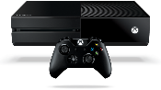
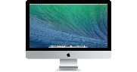 | 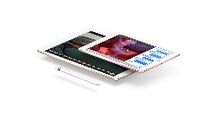
 | 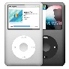

What are the benefits of multimedia devices?
Benefit | Example
Immediacy | On demand media, instant messaging
Access | User-friendly, inexpensive
Convenience | User-friendly, free or cheap, global
Portability | Movement & flexibility, always connected
Connectivity | Social networks, global village

What are the two functions multimedia devices that will appeal to the users?
Personalisation & Interactivity
Personalisation | Interactivity
Logging in, usernames, avatars | Level of control, activity or game-play
Digital TV menus, hard disc video recorders | User-generated content, digital editing
Adapting interfaces | Hyperlinks/web addresses, uploads and downloads
Font features | Texting and emailing to participate
Music playlists | ‘Red button’ and TV menus
What are the benefits of these features?
You have been tasked with designing a radio and music multimedia app.
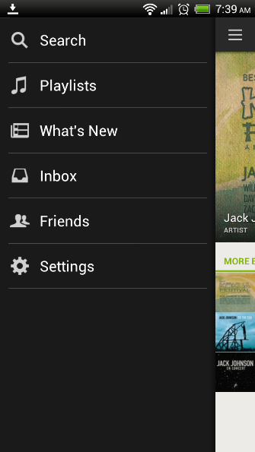
The app needs to appeal to the target user (15-30 year olds) and feature options that allow interactivity and personalisation.
You should aim to create concept art for what each interface for the app would look like and annotate what functgions buttons have. You can use photoshop to create your interface designs and annotate them on Word or PowerPoint.
Once complete upload to Weebly.

