Creative Digital Media Production Unit 8: Lesson 3
What might an organisation that operates over many countries be called?
International or multinational organisation.
What are the characteristics of this type of organisation?
You can see them around the world, and they make every type of media product like TV & Film, apps, games and music. The market-led decides on the types of products they make. They would a variety of products using synergy.
What might an organisation that operates over many countries be called?
National organisation.
Get some pictures of example organisations...
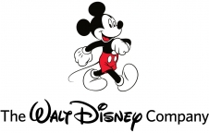
What are the characteristics of this type of organisation?
The area they cover is national coverage and distribution. The types of products they make is a national focus of products. They will compete with local and international markets.
What are the characteristics of local media?
They provide local services. The audiences are defined by geographical location. It focuses on local issues and content. They have a close relationship with the audience.
Get some pictures of example organisations...
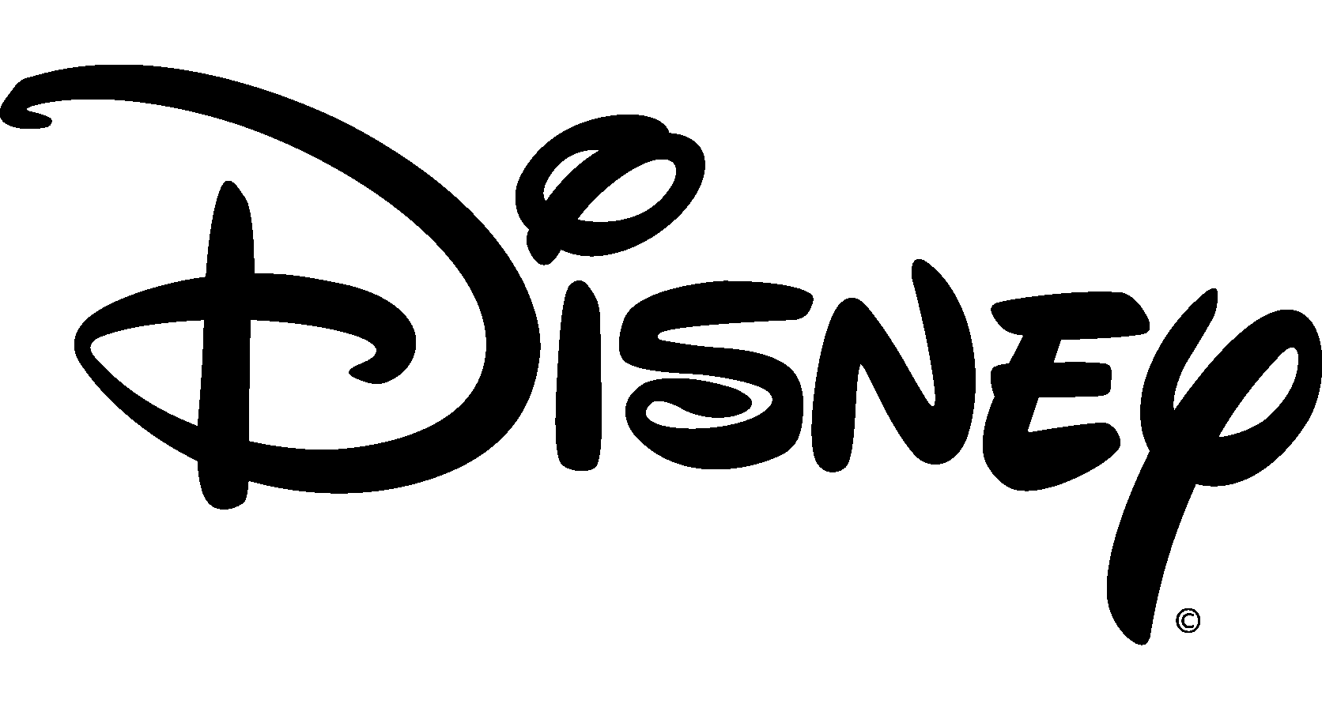

What are the characteristics of community media?
Serving the needs of a community or particular groups. Wide community participation. Audience defined by a small geographical area or special interests. Key role of volunteers within the organisation. Not-for-profit organisation, diverse content & gives training opportunities.
Get some pictures of example organisations...

Write down definitions for...
Vertical Integration | Horizontal Integration
This is where an organisation owns companies throughout the production process. | Organisations that own more than one company across a media sector(s).

