LEARNING OUTCOME 1;
In order to complete this learning outcome you should select and analyse 3 different interactive media products from different sectors e.g. websites, apps, DVDs, games, Audio guides

INTERACTIVE MEDIA PRODUCT REPORT
Name of interactive media product | No Man’s Sky
Product Image | 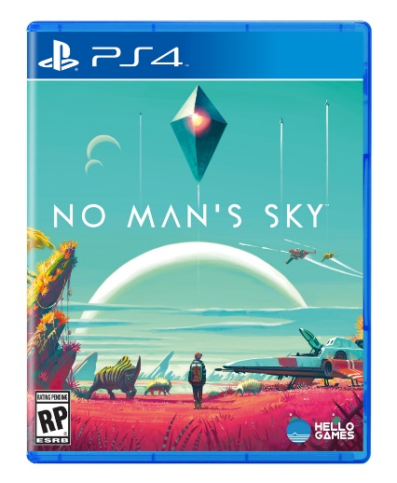
Product Type: e.g. websites, apps, DVDs, games, Audio guides | Game
What is the purpose of this product: e.g. educational, entertaining, informative | No Man’s Sky is a computer game available on the Playstation & PC games platforms. It’s main purpose is for the entertainment of its users.
Identify at least 3 considerations that have been made in the design production phase; | 1. The target audiences age rating is 7+ taking into account the suitability of the content  2. As an interactive 3D game it requires a number of skills to produce it including coding and 3D modelling as well as traditional concept art skills.  3. It is about space exploration and therefore considers scientific information about the environments and creatures that inhabit the world.

Name of interactive media product | Poster for Moana
Product Image | 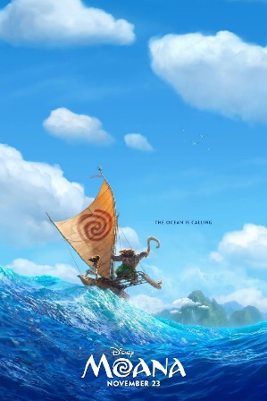
What is the purpose of this product | Animated movie
Identify at least 3 considerations that have been made in the design production phase; | 1. This has been designed for young children with parental guidance.  2. 3D animation requires people to animate using computers.  3.

Name of interactive media product
Product Image
What is the purpose of this product | Drama movie
Identify at least 3 considerations that have been made in the design production phase; | 1. This has been designed for audiences with parental guidance over 13 years of age.  2. This is about an historic war event. They have to research the time and dates of the events about an historic war event. They have to research the time and dates of the event.  3.

Name of interactive media product
Product Image | 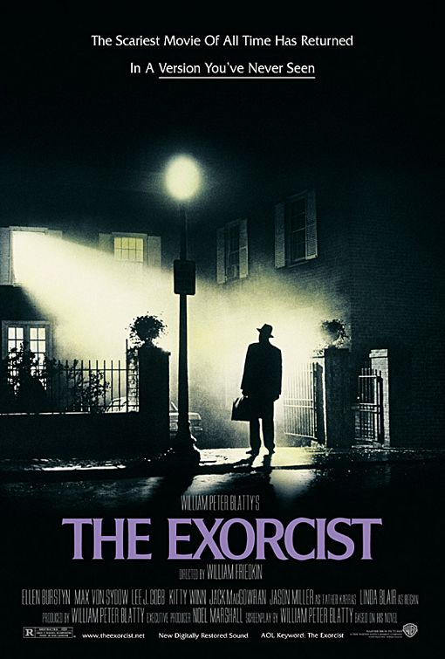
What is the purpose of this product | Horror film
Identify at least 3 considerations that have been made in the design production phase; | 1. This has been designed for restricted audiences over 18 years of age.  2. This is a fictional story/film.  3. Based on Christianity.

