Surrealism

What is surrealism?
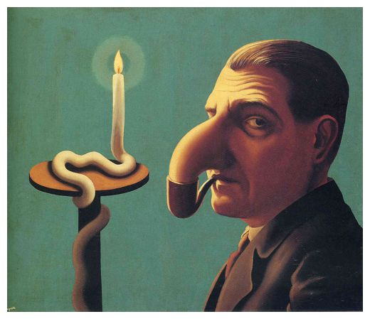
Surrealism is a 20th century cultural movement that began in the early 1920s, it was best known for its visual artworks and photography, and it was used to express the unconsciousness of the artist and yourself, because of the artist’s imagination.
For example, in the first image I chose, I would describe it as freaky and weird because of the way the man in the picture is putting his nose inside a pipe. RENÉ MAGRITTE (1898-1967) painted this image in 1936. The name of the painting is ‘The Philosopher’s Lamp’.

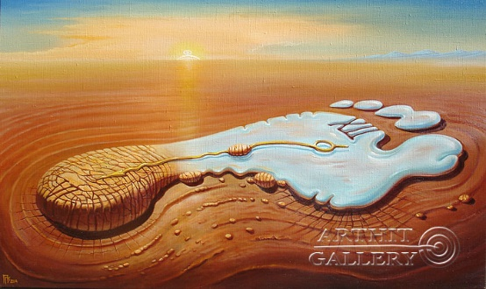
In the second image I chose, I would describe it as if you were looking at a clock in the dessert and that I think this ‘clock’ looks like a footprint and that it has melted a few hours ago, because it is either in the dessert or on an island where no one goes. Gennady Privedentsev painted this image. The name of the painting is ‘Footprints of Time’.

