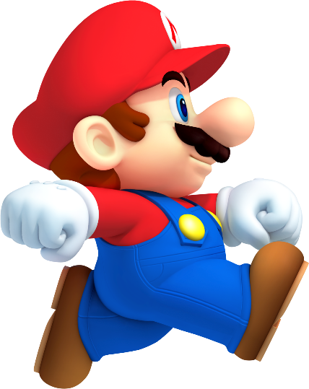
Unit 4.2
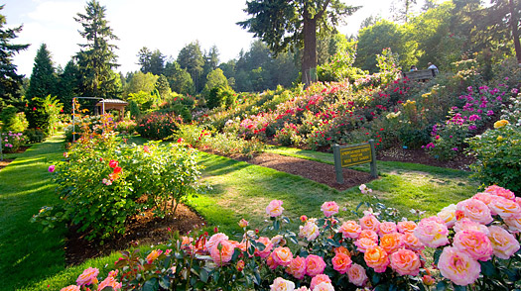

The first image I chose was a PNG image of Mario. This image is used to let people know that they want to play Super Mario on the Wii and that some users want to use the image for making a background of your own. This image was created with grey and white patterns behind the picture so that the people who research the image will know that it is a PNG image and that they can put their own background behind it.

The second image I chose was a JPEG image of a summer garden. This image is used to let people know that they want to visit that place and that it shows us what a garden looks like. This image was created to be an image on Google that people can research to illustrate what a garden looks like. I think it was taken as a photograph and then posted on the internet and that it’s uploaded as a JPEG.

Seb Sandford

